**Tableau Superstore Different Charts**

1. Profit Vs Subcategory

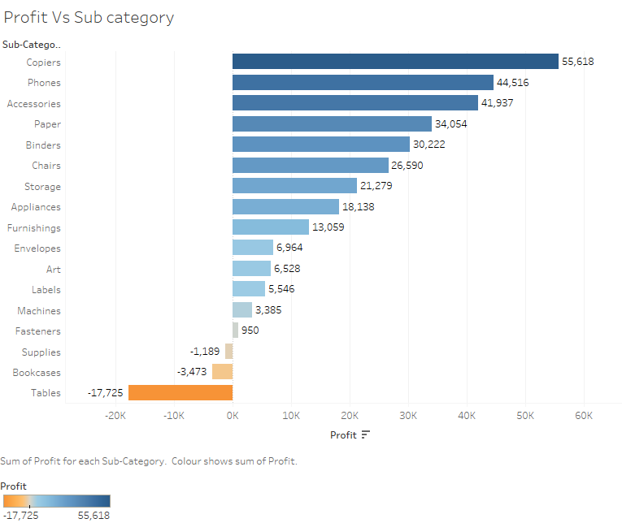

2. Sales & Profit by Region

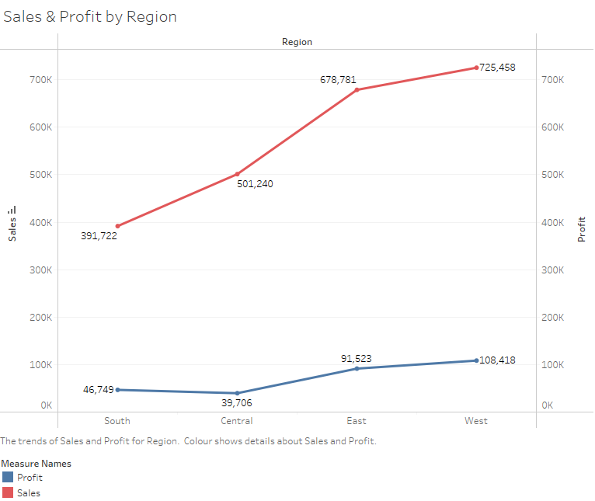

3. Sales & Profit Number by Segment

